27.06.2016

In first day of my industry training, I met with other interns and teammates that I work with during my internship.In general , there is different eight Software Development team and each group has own sub-teams. My team is YG-1 . My team have three sub-team which are trial balance and balance sheet , accounting systems and inventory systems.After I met with team leaders and teammates , I figured out that what each team are working on and which program they are using with.At the same time, they have requested a new computer and internet line for me . In Halkbank IT , there is senior security systems that protect information security .(No connection between usb port and computer ,no optical reader or no access for most internet sites).So there is no way to get an information extraction.

28.06.2016

Second day of my internship, my team have made a decision that what I develop during my internship. They want me to develop a system that record , monitor ,update and delete user requisitions.This system is going to run on web-based platform so I have to code it with c# & ASP.NET using Microsoft Visual Studio 2010 and Microsoft Access 2007 SQL Server.



29.06.2016

Third day of my internship , my teammate shared a documentation of asp.net and c# so I have the information for while developing system and creating structure of elements.After all , I start to discuss with my teammates about design and requirements of structure.I drew interface of system before I put elements on program.

30.06.2016

I try to figure out the requirements of project and create project file in Visual Studio 2010.I had the information about general page structure and database tables but I have to create a new database during I develop my system since there is no permission for interns to use Halkbank Database Server ports because of information security. So they want me to create a new database and test program before they connect it to their own server.So I created a database table which is given below .In this database table , I have searching criteria.User can input anything to search user requisitions in tblBilgi (Figure 1)

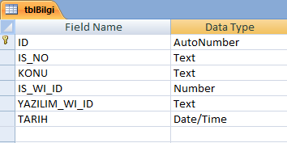

Figure 1 : tblBilgi

01.07.2016 – 02.07.2016

I create interface of login page and integrate connection to Halkbank system to users can use system by their own username and password.

I cannot show login page code behind because of information security but the main point of those connection are adding .dll files of Halkbank user System into project. I cannot show the .dll files too because of security. Interface of login page is completely done which is given below (Figure 2)
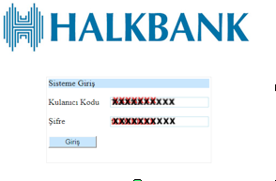
Figure 2 : Interface of Login System

04.07.2016 – 08.07.2016

I moved to Searching Page interface after login page is done.All I need to put elements which allows searching, according to searching criteria and a gridview, to list result which returns from database server. My teammates want me not to allow multiple search so I designed searching criteria based on radio button. Search button controls which radio button is checked before SQL query and add textbox value into SQL query according to checked radio button input.

Code Sample:

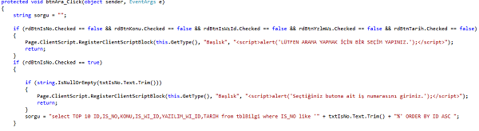
Figure 3 : Code sample of Search button

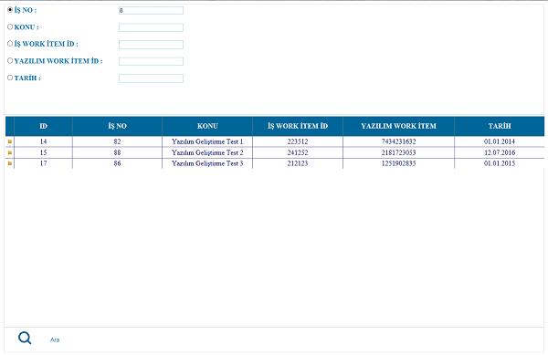
Figure 4 : Image from first version of Searching Page

11.07.2016 – 12.07.2016

In Searching Page , I have to define two more button to move between gridview pages and gridview has to list ten item per page in ascending order. So SQL query has to change and I used nested select query.

Code Sample :

Figure 5 : Code sample of Back button

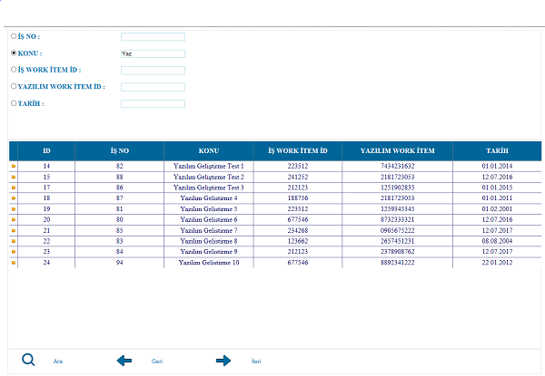

Figure 6 : Interface of Next-Back button

13.07.2016 – 15.07.2016

In Searching Page , I have added button per row in gridview as u see above in (Figure 6 ) , this button redirects new page which is Detail Page with selected index row item id

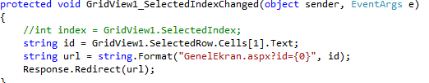
Figure 7 : Code Sample of Selected Row Index ID

After this complete , id which passed from gridview has to return variables from database server in third page of system which is Detail page. Detail page has to show everyting about user requisitions .I created third page and put search criteria, then fix the connection between Searching and Detail Pages and write down SQL queries to fill empty textboxes.

Code Sample :

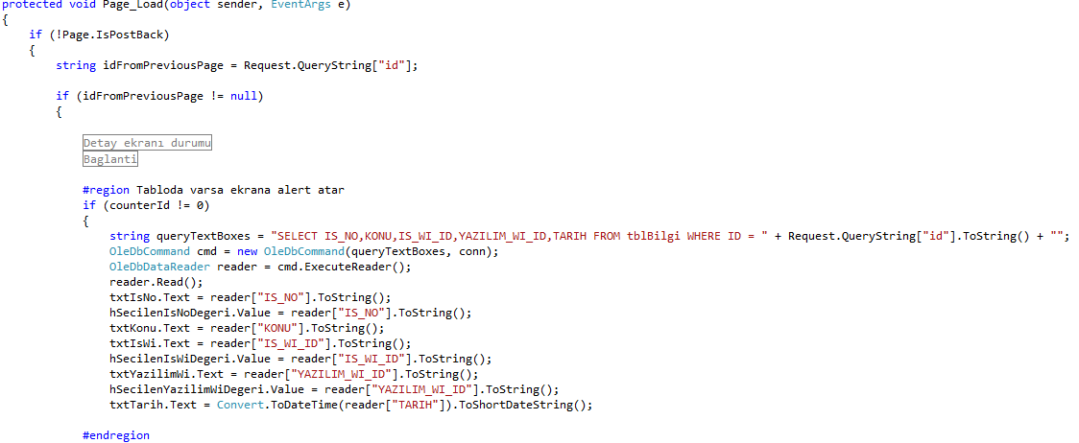
Figure 8 : Code Sample of Fill Search Criteria in Detail Page Corresponding ID

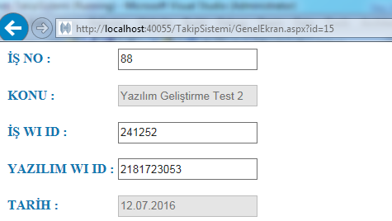
Figure 9 : Interface of Detail Page Search Criteria After Selected Row Index ID

System does not allow that user is not able to edit searching criteria so all fields in searching criteria are disabled.Whereas there are another details of corresponding table id which are the program names that return from database. I have to create my third database tblKod , has 3 column which are given below (Figure 9)

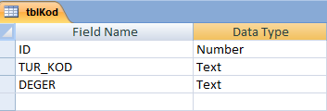
Figure 10 : tblKod

ID , is the same ID from tblBilgi , also selected row index “ ID “ , in detail page , I have to list this database table “DEGER” values at the rest of page .

TUR_KOD , is the information about the programs which is edited and used. (Main part of the system is based on TUR_KOD).All TUR_KOD column value has unique description and value to keep data.

DEGER , is the program names based on TUR_KOD values ( TUR_KOD = 1 , Keep “STATEMENTS” about the corresponding “IS_NO”)

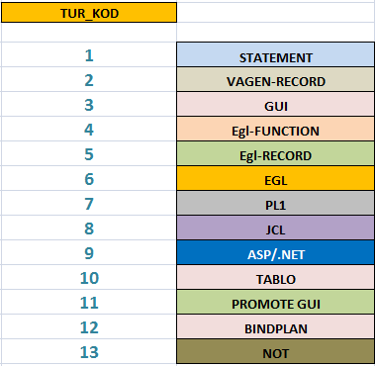
Figure 11 : TUR_KOD Values

18.07.2016 – 20.07.2016

In Detail Page , I put twelve listbox and one textarea . Those listboxes are refer every TUR_KOD value and textarea refers to NOTE. Another hand I put an UPDATE button to update changed listbox values to database server. Design of twelve listboxes and textare takes time by using CSS such as alignment , size and other design things.After complete the connection between database and listboxes , there has no problem about showing the values in listboxes.

Code Sample :

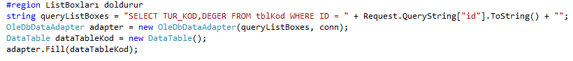
Figure 12 : Fill Datatable with TUR_KOD Values.

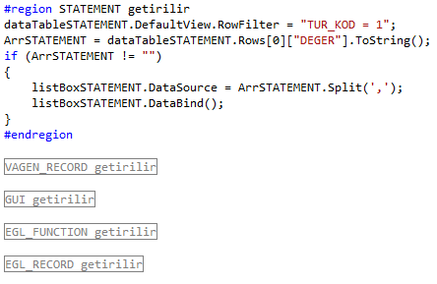
Figure 13 : Fill Every Listbox Based Constant TUR_KOD Values.

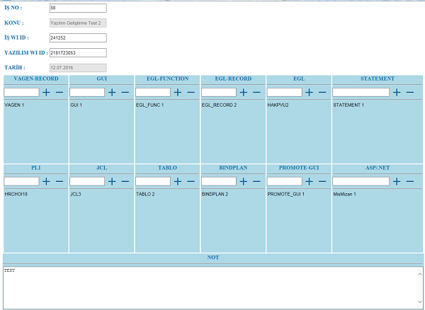

Figure 14 : Interface of Detail Page Filled Elements by Selected Row Index ID.

18.07.2016 – 21.07.2016

In Detail Page , Listboxes fills with no problem but I have to add options which are Add New Item and Delete Item from listboxes.Also user cannot input new item so user has to pick from somewhere.It shows that I have to create another database table which allow users to pick list item corresponding listbox. Third database table tblProgram is given below (Figure 14)

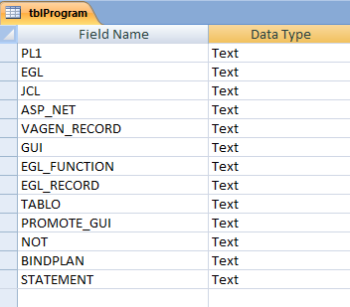
Figure 15 :tblProgram

My teammates request that user add new item into listbox onclick listbox add button , then new popup window appears and user input to sort programs or show them all in gridview.

Code Sample :
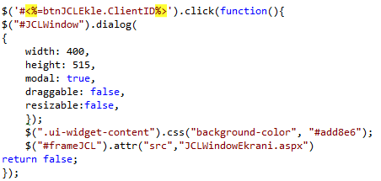
Figure 16 :Javascript code that open popup onClick

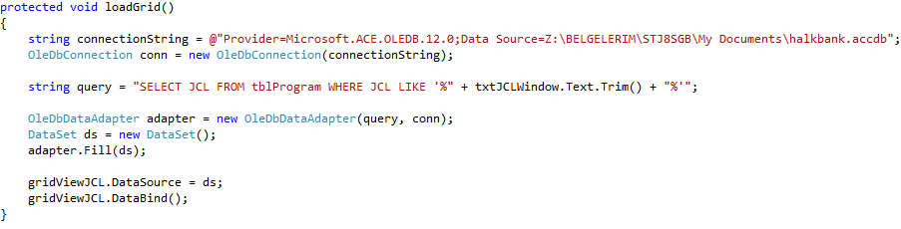
Figure 17 : Code Sample that fill Gridview with JCL programs from tblProgram table in Database

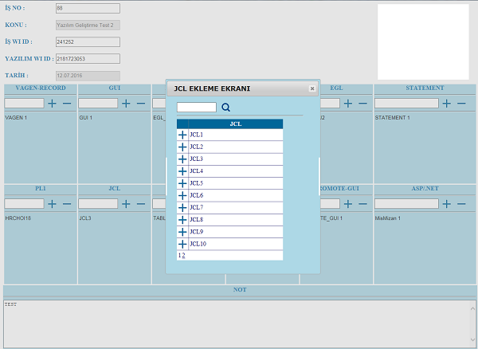
Figure 18 :Interface of Gridview and Popup after user click Plus Button

Code Sample:

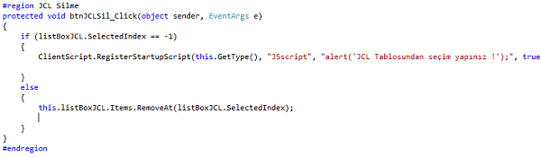
Figure 19 :Code Sample of Delete item from ListBoxes

22.07.2016

In Searching Page , I have to add new two method which are clear and new record buttons.
Clear button is clear all text fields and results which are listed in gridview .

Code Sample :
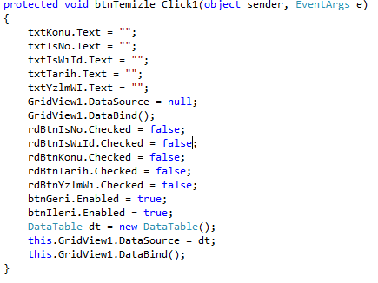
Figure 20 :Code Sample of Clear Button in Searching Page

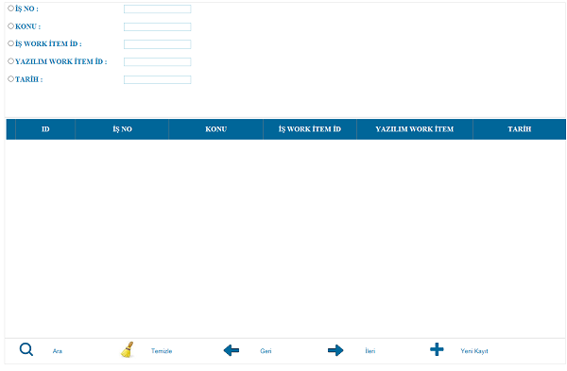
Figure 21 :Interface of Searching Page after Clear Button and New Record button added

25.07.2016 – 26.07.2016

After added New Record Button in Searching Page , I have to create a new page for new Record, where this new record page has elements as detail page so I started building detail page as new record page. Page Load code is given below (Figure 22)

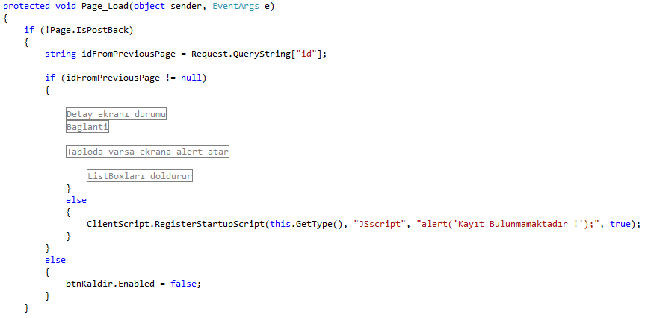
Figure 22 :Code Sample that checks User Selected New Record Or Detail Of Record

In this New Record Page , our searching criteria has role as new record .This time ,user input “KONU, TARIH” by hand and “IS-NO ,IS-WI-ID , YAZILIM-WI-ID” from database table , then it insert the informations into tblBilgi. So I have to create new database table for user to select three of searching criteria. Fourth database table tblBim which is given below (Figure 23)

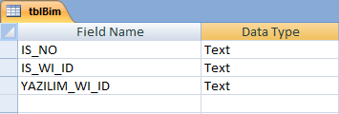
Figure 23 :tblBim

User select IS_NO , IS_WI_ID and YAZILIM_WI_ID values from this table and input other two value.After all , new record is saved into tblBilgi where our searching criteria execute sql queries.
I have designed new record page by adding plus button near the textfields that user is not allowed to input.

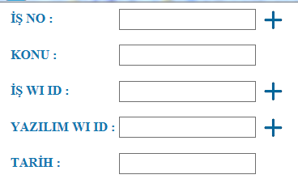
Figure 24 :New Record Page Searching Criteria

Plus buttons opens a new popup window using javascript function.And same progress goes during popup opened like listbox item adding progress.There is a gridview which list items from tblBim.

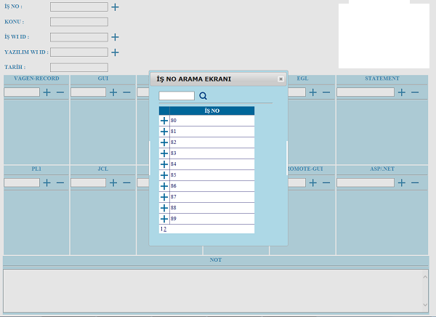
Figure 25 :New Record Page IS NO Adding Popup
27.07.2016 – 29.07.2016

At the same time , on new record method , two database table has to be insterted which are tblBilgi and tblKod. tblBilgi is going to be inserted by Searching criteria textbox values and tblBilgi is going to be insterted by Listboxes and textarea.No matter if listboxes are empty or not.
New Record generates new unique ID before inserting into tblBilgi.

Code Sample :

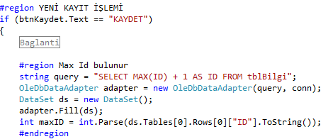
Figure 26 :New Record Page , Generate new ID for new Record.

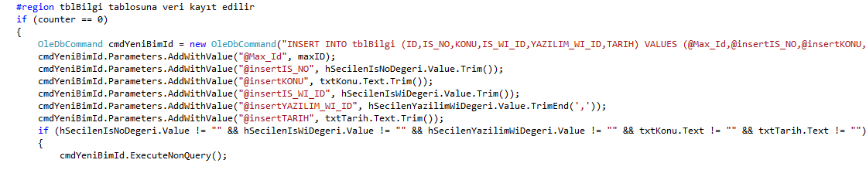
Figure 27 :Code Sample that shows how to Insert into tblBilgi

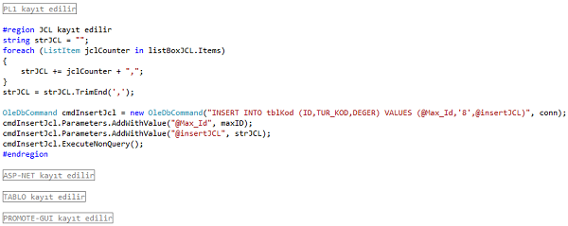
Figure 28 :Code Sample that shows how to Insert into tblKod

01.08.2016 – 02.08.2016

After New record is done , I have to create new methods which are Delete , Clear and HomePage buttons in New Record Page and Detail Page.Delete Button is not available in New Record Page.

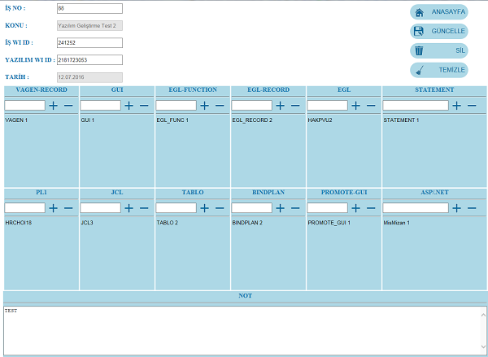
Figure 29 : Interface after Homepage – Delete – Clear Button defined in Detail & New Record Page

Code Sample :

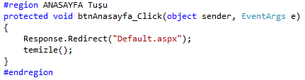
Figure 30 : Code Sample Of HomePage Button

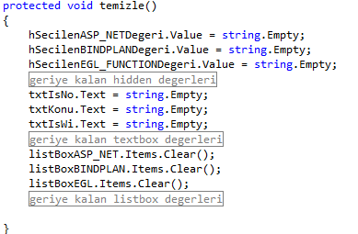
Figure 31 : Code Sample Of Clear Button

Delete Button is only available Detail Page.

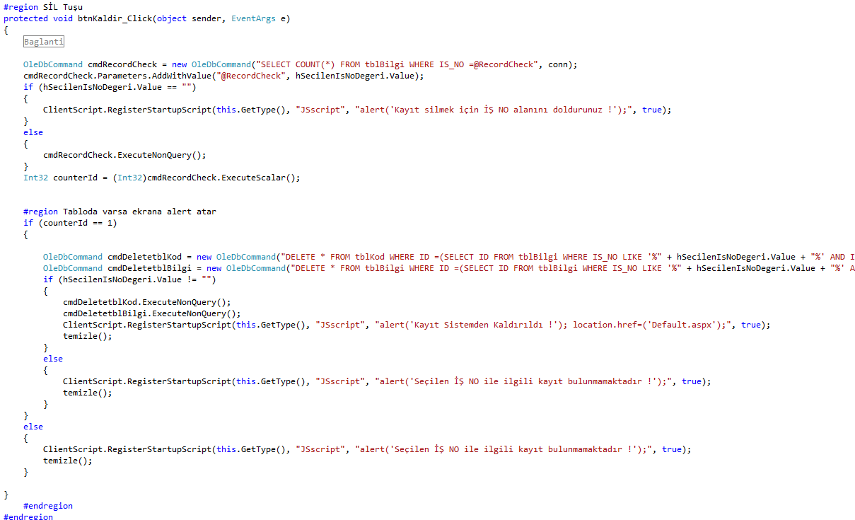
Figure 32 : Code Sample Of Delete button

03.08.2016 – 05.08.2016

After all requirements of system completely done , I started to test and protect some of my code parts.Main problem of all action was searching criteria textbox values resetting after popup opened or listbox item deleted.Also after Updated to database server , textfields are resetting.Another main problem was protection from users who input URL by hand to crash system. For Instance , if you enter a different [id] in URL of Detail page you will be warned.

Some Error and Info Messages added to system as warn the user.

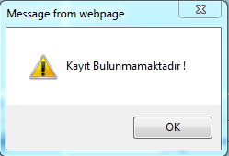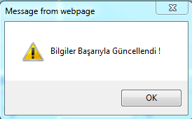
Figure 33 : Error Alert – No Record Found ! Figure 34 :Info Alert – Successfully Updated !

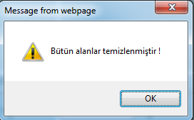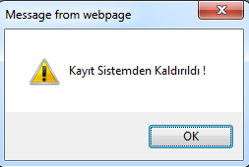
Figure 35 : Info Alert – Successfully Cleared ! Figure 36 : Info Alert – Successfully Deleted !

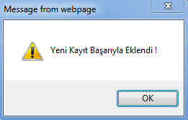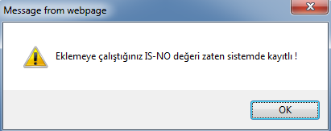
Figure 37 : Info Alert – Successfully Recorded ! Figure 38: Error Alert – Already Recorded !

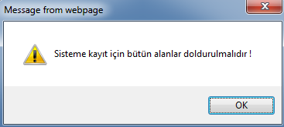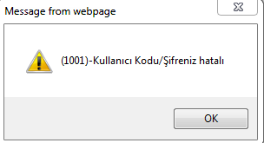
Figure 39: Error Alert – Fill All Fields For New Record ! Figure 40: Error Alert – No Username /Password !

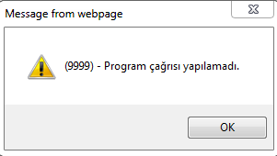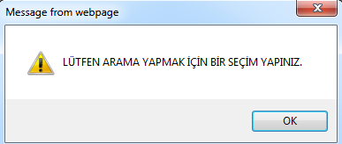
Figure 41: Error Alert –Username/Password is Null ! Figure 42: Error Alert – Select Searching Crierion

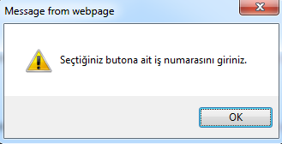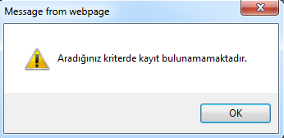
Figure 43: Error Alert – Enter input Selected Radio Button! Figure 44: Error Alert –No Record with Enrty !

08.08.2016 – 11.08.2016

Last week of my internship , I have tested system carefully and I made some code cleanups, bug fixes . Then , we start to integrate system to Halkbank Database Server. During this time , I have started to write my training industry report .

